

**Project By:**

**Shair Ali**

**Project name**

**Hotel management**

**Submitted To:**

**Sir Fawad & Rana Marwar Hussain**

**SAP_ID**

**15399**

**Topic**

**DSA Project Project**

**Section:**

**3rd B**

**Based on:**

**Link list | Oop concepts | File handling | pointers |**

**Data Structure And Algorithm topics**

**Code Availible On Link of Github:**

**<https://github.com/ShairALiMughal/Hotel-Managment-System-C-.git>**

**Abstract:**

I create the hotel management system in C++ using the link list [data structure]

The hotel management will save record of rooms and the manager can add the new guest data

Who came for stay in hotel, also guest can also access his information by giving the correct information

* **Login as**

1. **Manager**
2. **Guest [that staying in room] [guest can access his info with his password]**

* **Services**

**It will provide the following functions**

1. Adding a guest data
2. Modify the data
3. Free the room
4. Display all record of booked rooms
5. Searching a particular room information
6. Guest can see his data [by his password that guest save when deal his room]
7. Payment information

* **Loading Screen**



* **Cord Class use to go any location on Compiler Screen Not the Spaces or /t**
* **The Main Screen**

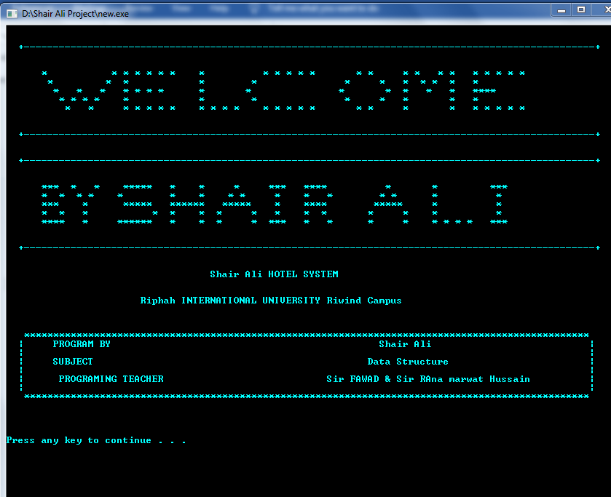

* 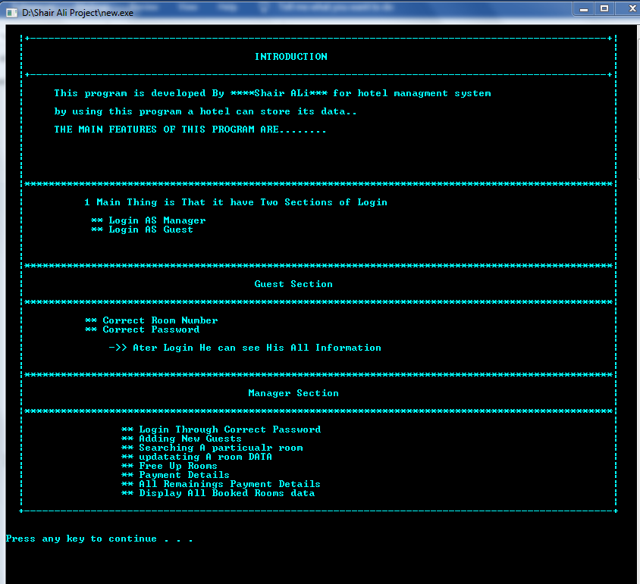**Introduction The features:**
* **Sections:**

**Login As Admin ( Have to Enter the Password 🡪shair🡨)**

**Admin Functionalities:**

**🡪**adding new rooms

🡪Searching a specific room info

* updating the specific room info
* Free a Room
* Payment details
* Seeing all booked rooms
* File handling minimize the lines of code for Graphic Works
* remaining of all rooms (except 0 remaining)
* Auto Payment calculation on base of days to stay
* File handling also room data will be fetched in case of exit
* The data of rooms will remain saved in case of Exit
* **User Login**

User can login and see his all info

User can see his info only in case of Correct * room_no and

Password that he made on booking time

* **The Login Page:**

**1 for manger login**

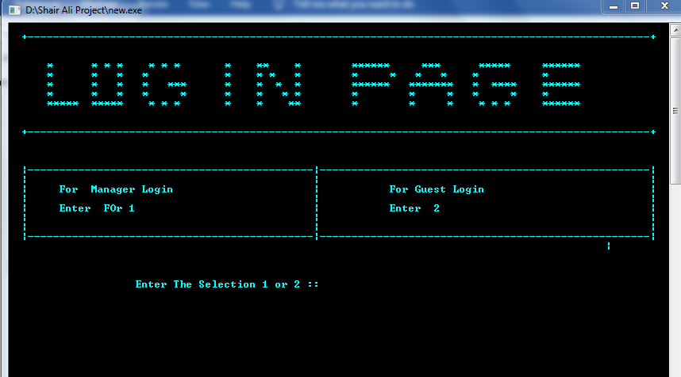**2 for user Login**

**Case of wrong Entry:**

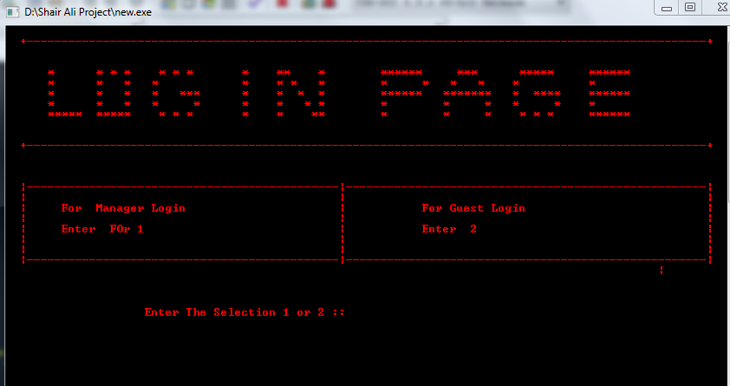

**Selecting 1**

**Manger Login (Correct Password)**

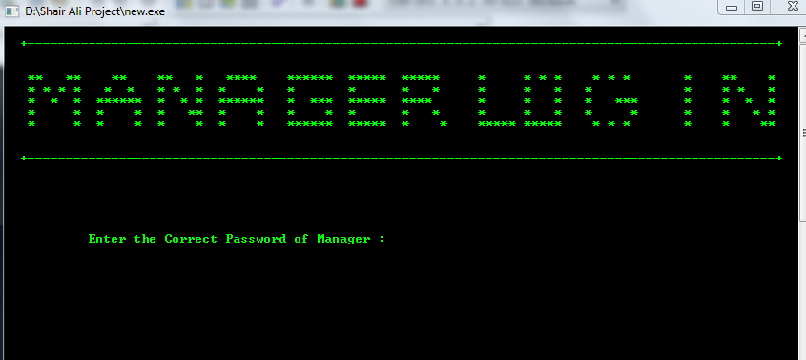

**In Case of Wrong Password**

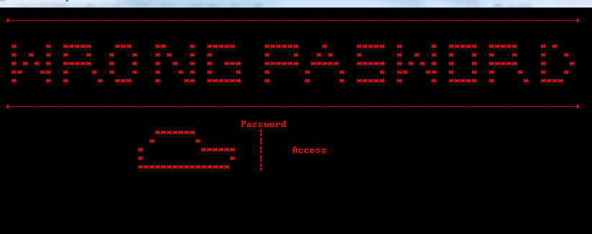

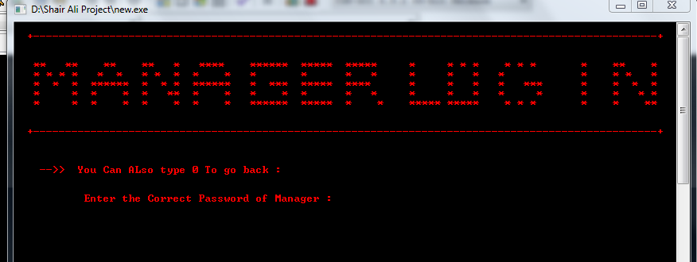

**Entering Correct Password (shair):**

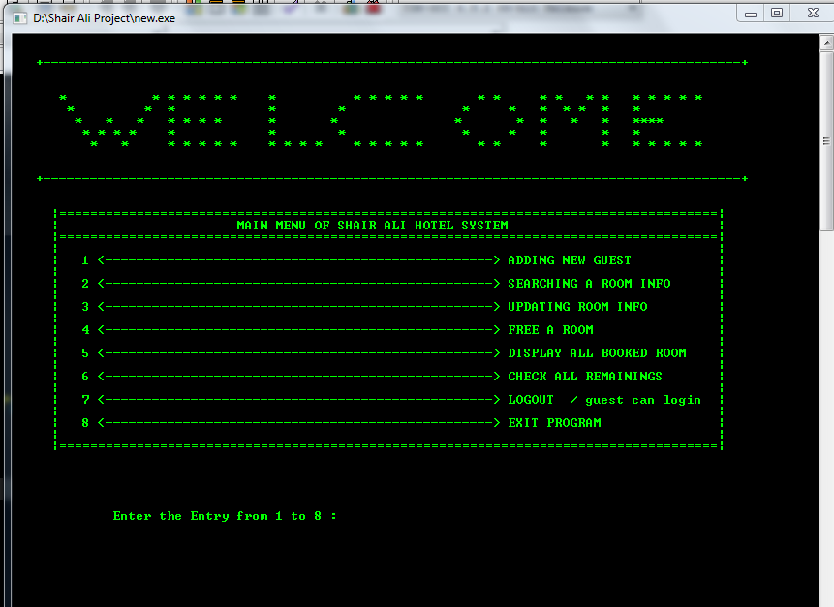

**Numbers of Functionality of Admin**

**Adding new room**

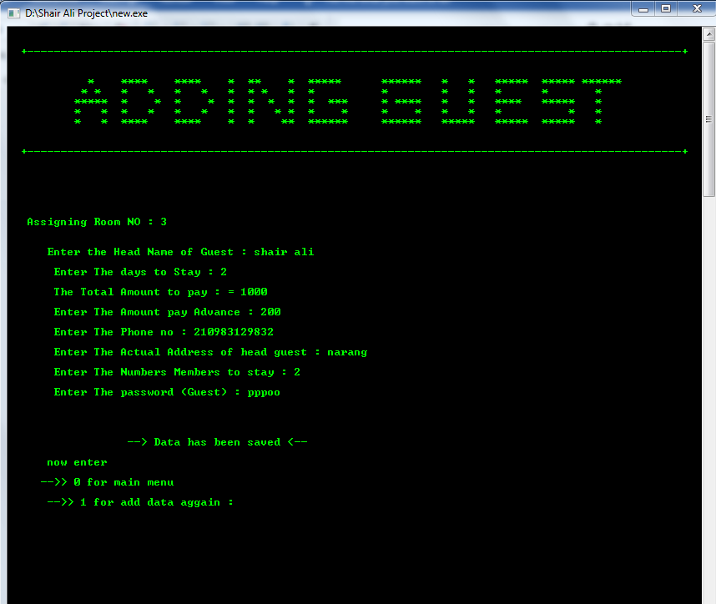

**0 for back and 1 add again**

* **Viewing all Booked rooms**

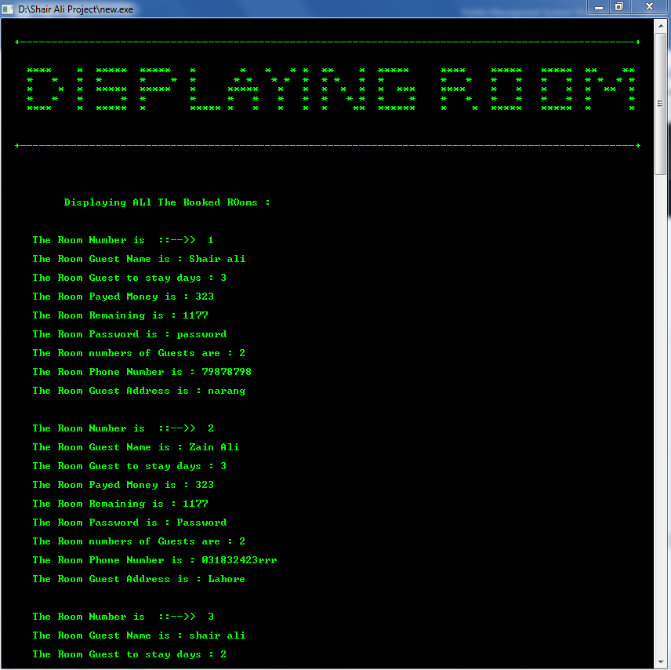

* **Viewing all remains from rooms**

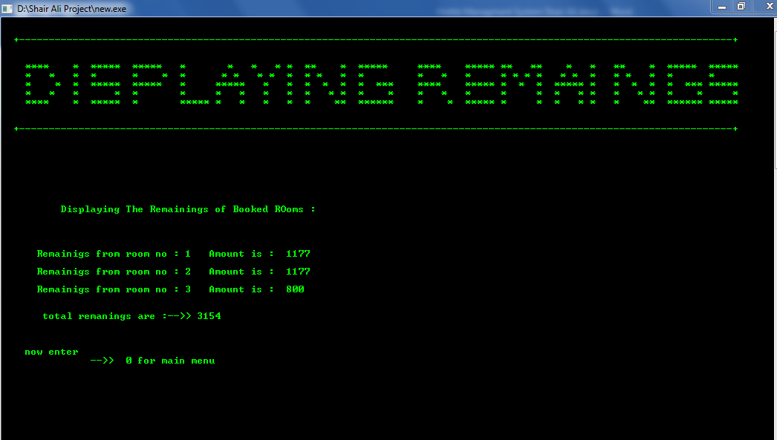

**Like that we can perform all the room operations**

**Free room**

**Update**

**Check info**

**Go to login page**

* **User Login in**

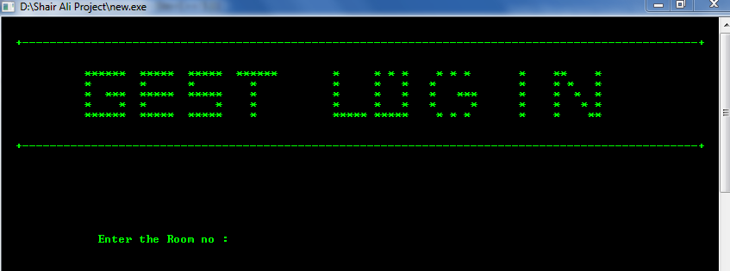

**Entering incorrect room no and password**

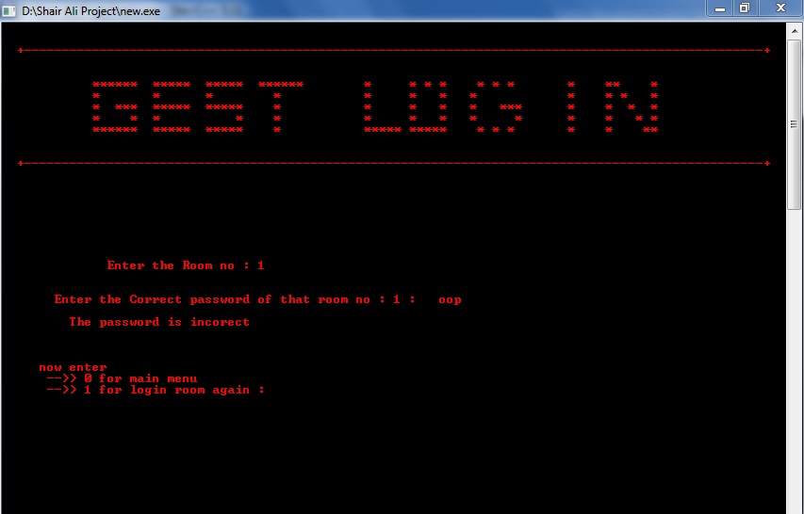

**Entering Correct Info**

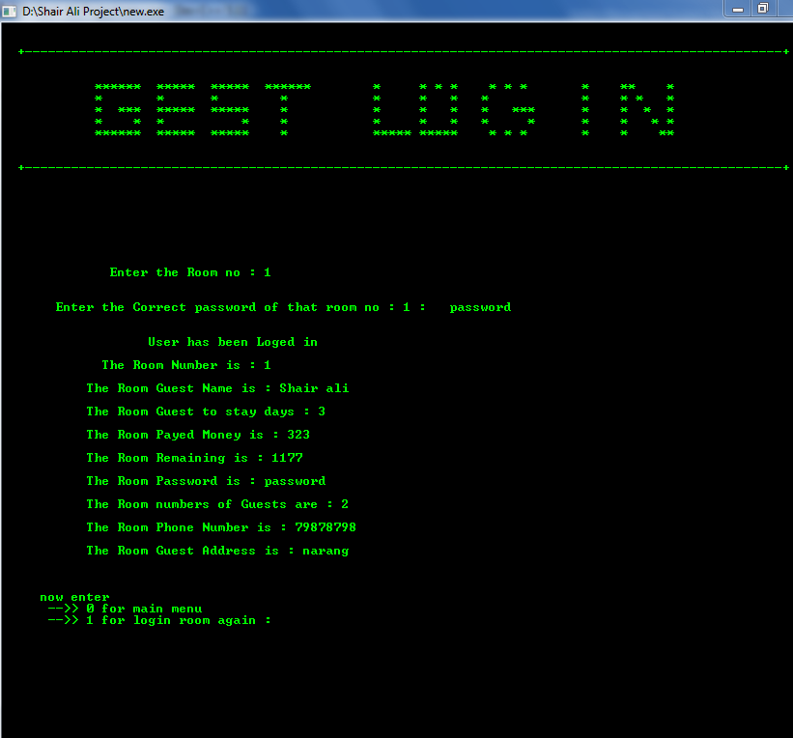

**That’s All …………………………………….**